Star Age logic + UI
Colonies

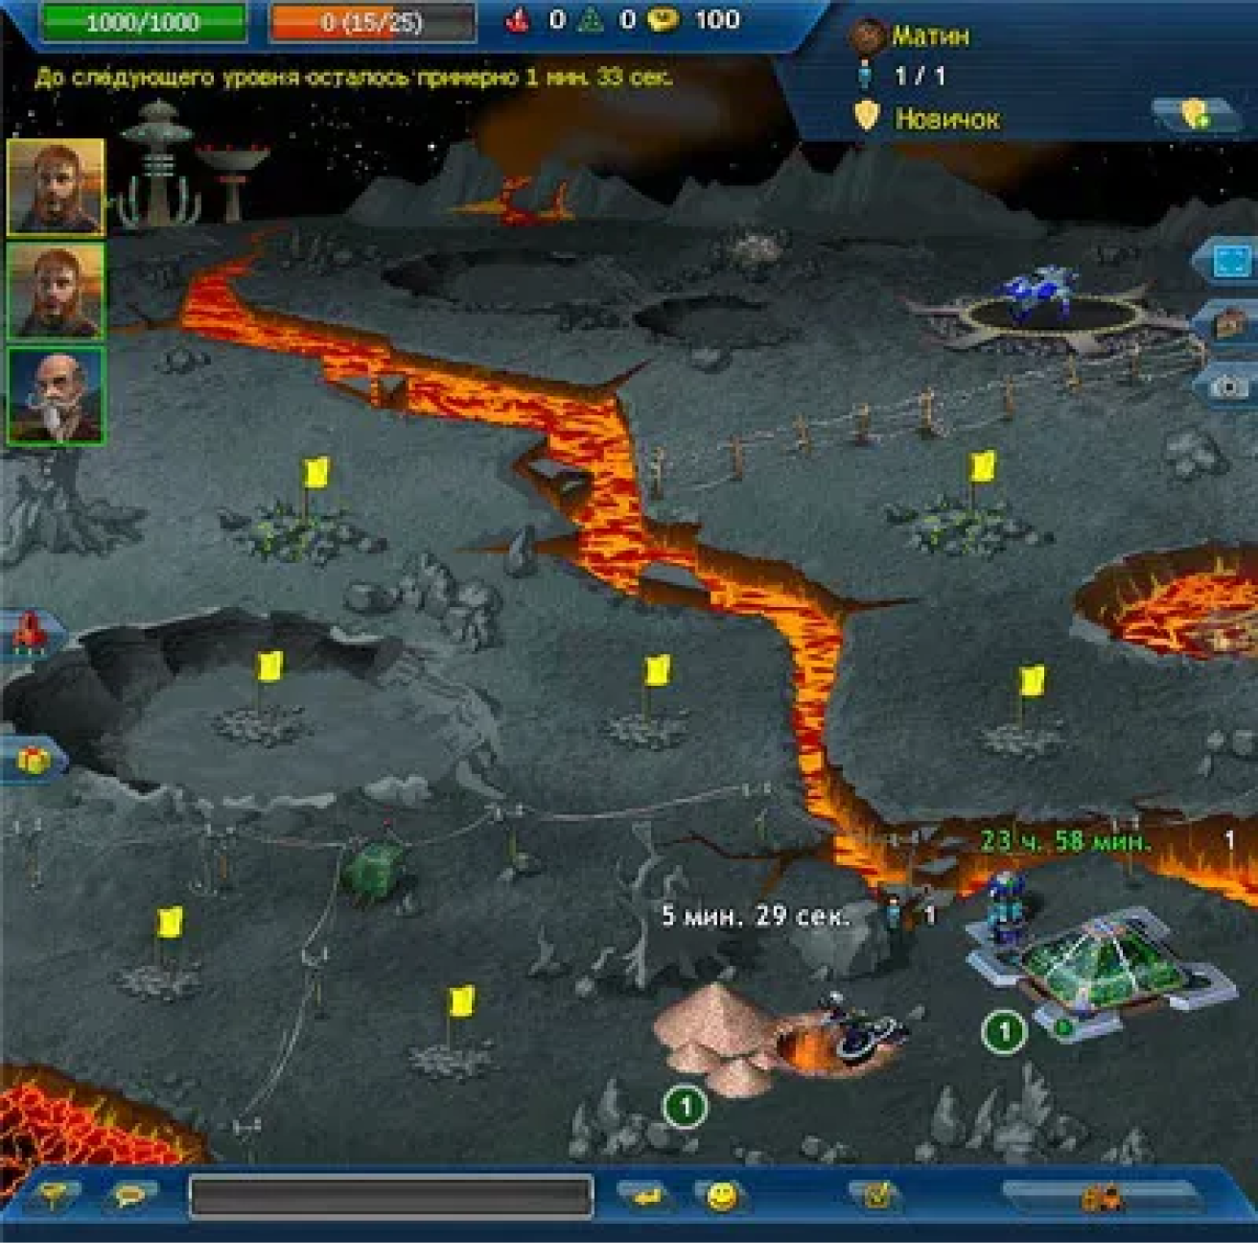

This is what the colony on the first planet looks like, a rocky planet with lava and craters.
The user has 9 locations where they can build various structures, such as:
stone quarry
uranium quarry
ice quarry
fuel production (2 uranium + 1 ice)
auction for selling goods (in the future, trade between players will take place through it), but for MVP it is an opportunity to simply sell goods
metal production (2 stone)
production of one-time repair kits (which give +20 HP to a ship in space) - (1 metal + 1 uranium)
production of ship accelerators (give +4 to speed in space for 30 seconds) - (1 fuel + 1 ice)
+ add everything that is already in the game documents
warehouse - allows you to store items (300 squares, for example, ice, uranium, etc. take up 1 square, a repair kit and an accelerator take up 2 squares (vertically))
hydroponics - provides population (necessary for some buildings to function) (consumes food and ice)
arms factory (allows you to manufacture rockets) (requires electronics + metal)

Stone mining: a first-level building mines 1 stone every 15 minutes, with a maximum of 5 stones that can be stored (to continue mining, these stones must be collected). The building itself looks like a quarry and has a label at the top + the building level number.
Uranium mining: similar logic. 1 uranium every 20 minutes. Maximum 5 uranium. The building looks like a factory.
Ice mining: looks like a well (1 ice every 5 minutes), maximum 5 ice.
Fuel production (2 uranium + 1 ice): the user can exchange 2 uranium and 1 ice for 1 level 1 fuel element. A fuel element will allow you to either craft an accelerator or fly to a neighboring system. 1 fuel is produced in half an hour. Maximum 4 fuels at a time.
Auction for selling goods: for MVP, this is an opportunity to simply sell goods - 1 ice - 2 coins, 1 stone - 3 coins, 1 uranium - 5 coins, fuel - 20 coins, metal - 15 coins, one-time repair kit - 50 coins, accelerator - 50 coins
Metal production: 2 stones for 1 metal, produced in half an hour, maximum 5 pieces at a time.
And so on according to this logic
In addition to the colony, there are also structures on the planet: basic

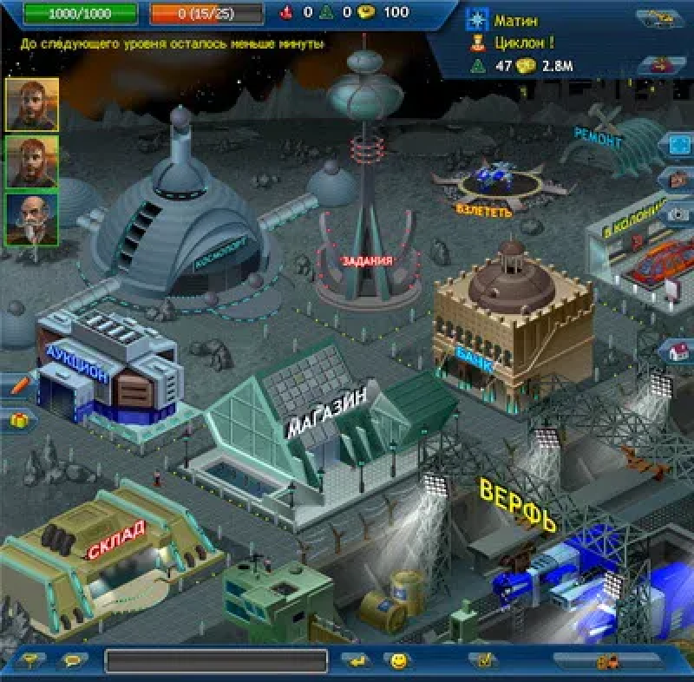
Auction - it will not be on mvp, but there will be trading between graphics here. A store where you can buy various resources (stones, electronics, etc.), as well as weapons, engines, and various modules for ships. A warehouse where various items mined in the colony or found in space are stored. Bank - will not be on mvp, spaceport - will not be on mvp. Tasks - there will be tasks such as transporting something somewhere or killing someone (a pirate, miner, etc.). Shipyard - there you will be able to buy various ships.

